NAME
Steven Seppälä

USER
sseppala

GROUP MEMBERS
N/A
LAB TWO:
More Basic Assembly Language Programming

13 March 2014

I) INTRODUCTION

In this lab we were given seven tasks to do. In these we experimented with branch control, external hardware, memory, and the UART system.
There was expensive branching in this lab, which is analogous to the loops in other languages, we used the branches to achieve things such as searching through 2,000 values.
This idea would then be built on in part three of the lab which asked us to implement a rotating pattern on the LED P-MOD. This would also lead us into the rest of the lab where we would be interacting with a terminal and take inputs and push things out to the screen.

II) SOLUTION APPROACH

I approached the first two parts of the lab from a programmers perspective. First I would need to get the values that I would test in this program and then store them into the memory. Once that was done I could test the case if A > B then if that was evaluated to true by the slt instruction, I would branch to subtract the X value from the Y value. Other wise X and Y values would be added together and then stored into my empty W value array.
Part two was somewhat simpler. I stored all 2K values that were given to us into a labeled array. From there I could pull it out one at a time and test the value. There were two tests performed on the number first, these were if it was less than -9K or greater than 9K. Once that passed another test was done based on which of the previous cases passed. If the value was less than -9K, I subtracted -18355 from the number, and if the result was zero, then I knew that the number I was looking at was -18355, this way I could count it in a separate register. If the over 9K test passed, I subtracted 24321 from the number, just like I did for the under -9K number.
Part three was simple, once I had the memory locations of the port and where the LED's were located, all that needed to be done was to send a 0x01 to the port, and then keep shifting the register until it reached 128, 2^7, or until it reached 1, 2^0, based on if it was going right to left or left to right respectively. Next I checked to see if the button locations in memory changed, they would only change when I pressed on the button, and they would change differently based on which button was pressed.
Parts four, five, six, and seven all used the UART on the board to accomplish sending and receiving serial data.
Part four was accomplished by recording into memory every key that was hit as it was sent back out to the screen. Once the enter key was stricken, the entire string that was typed in was retyped to the terminal.
Part five sends a character continuously to the terminal that is determined in the code, this is then read on the oscilloscope. Some wave forms of this are displayed below.

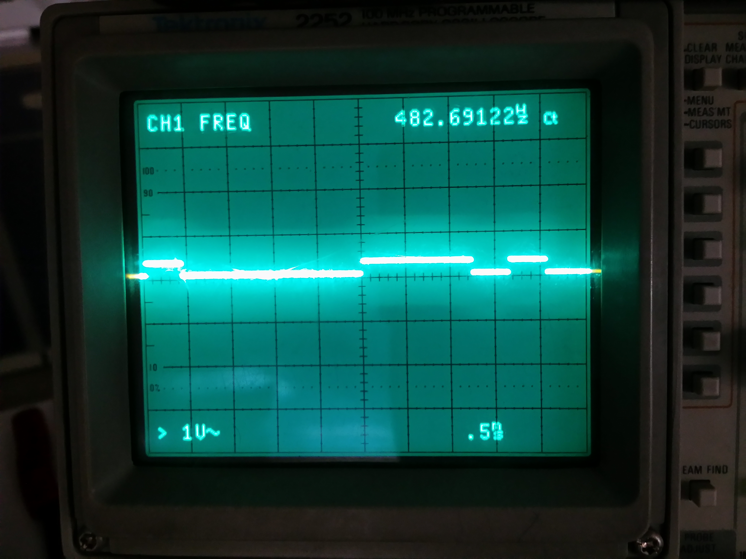

Space character

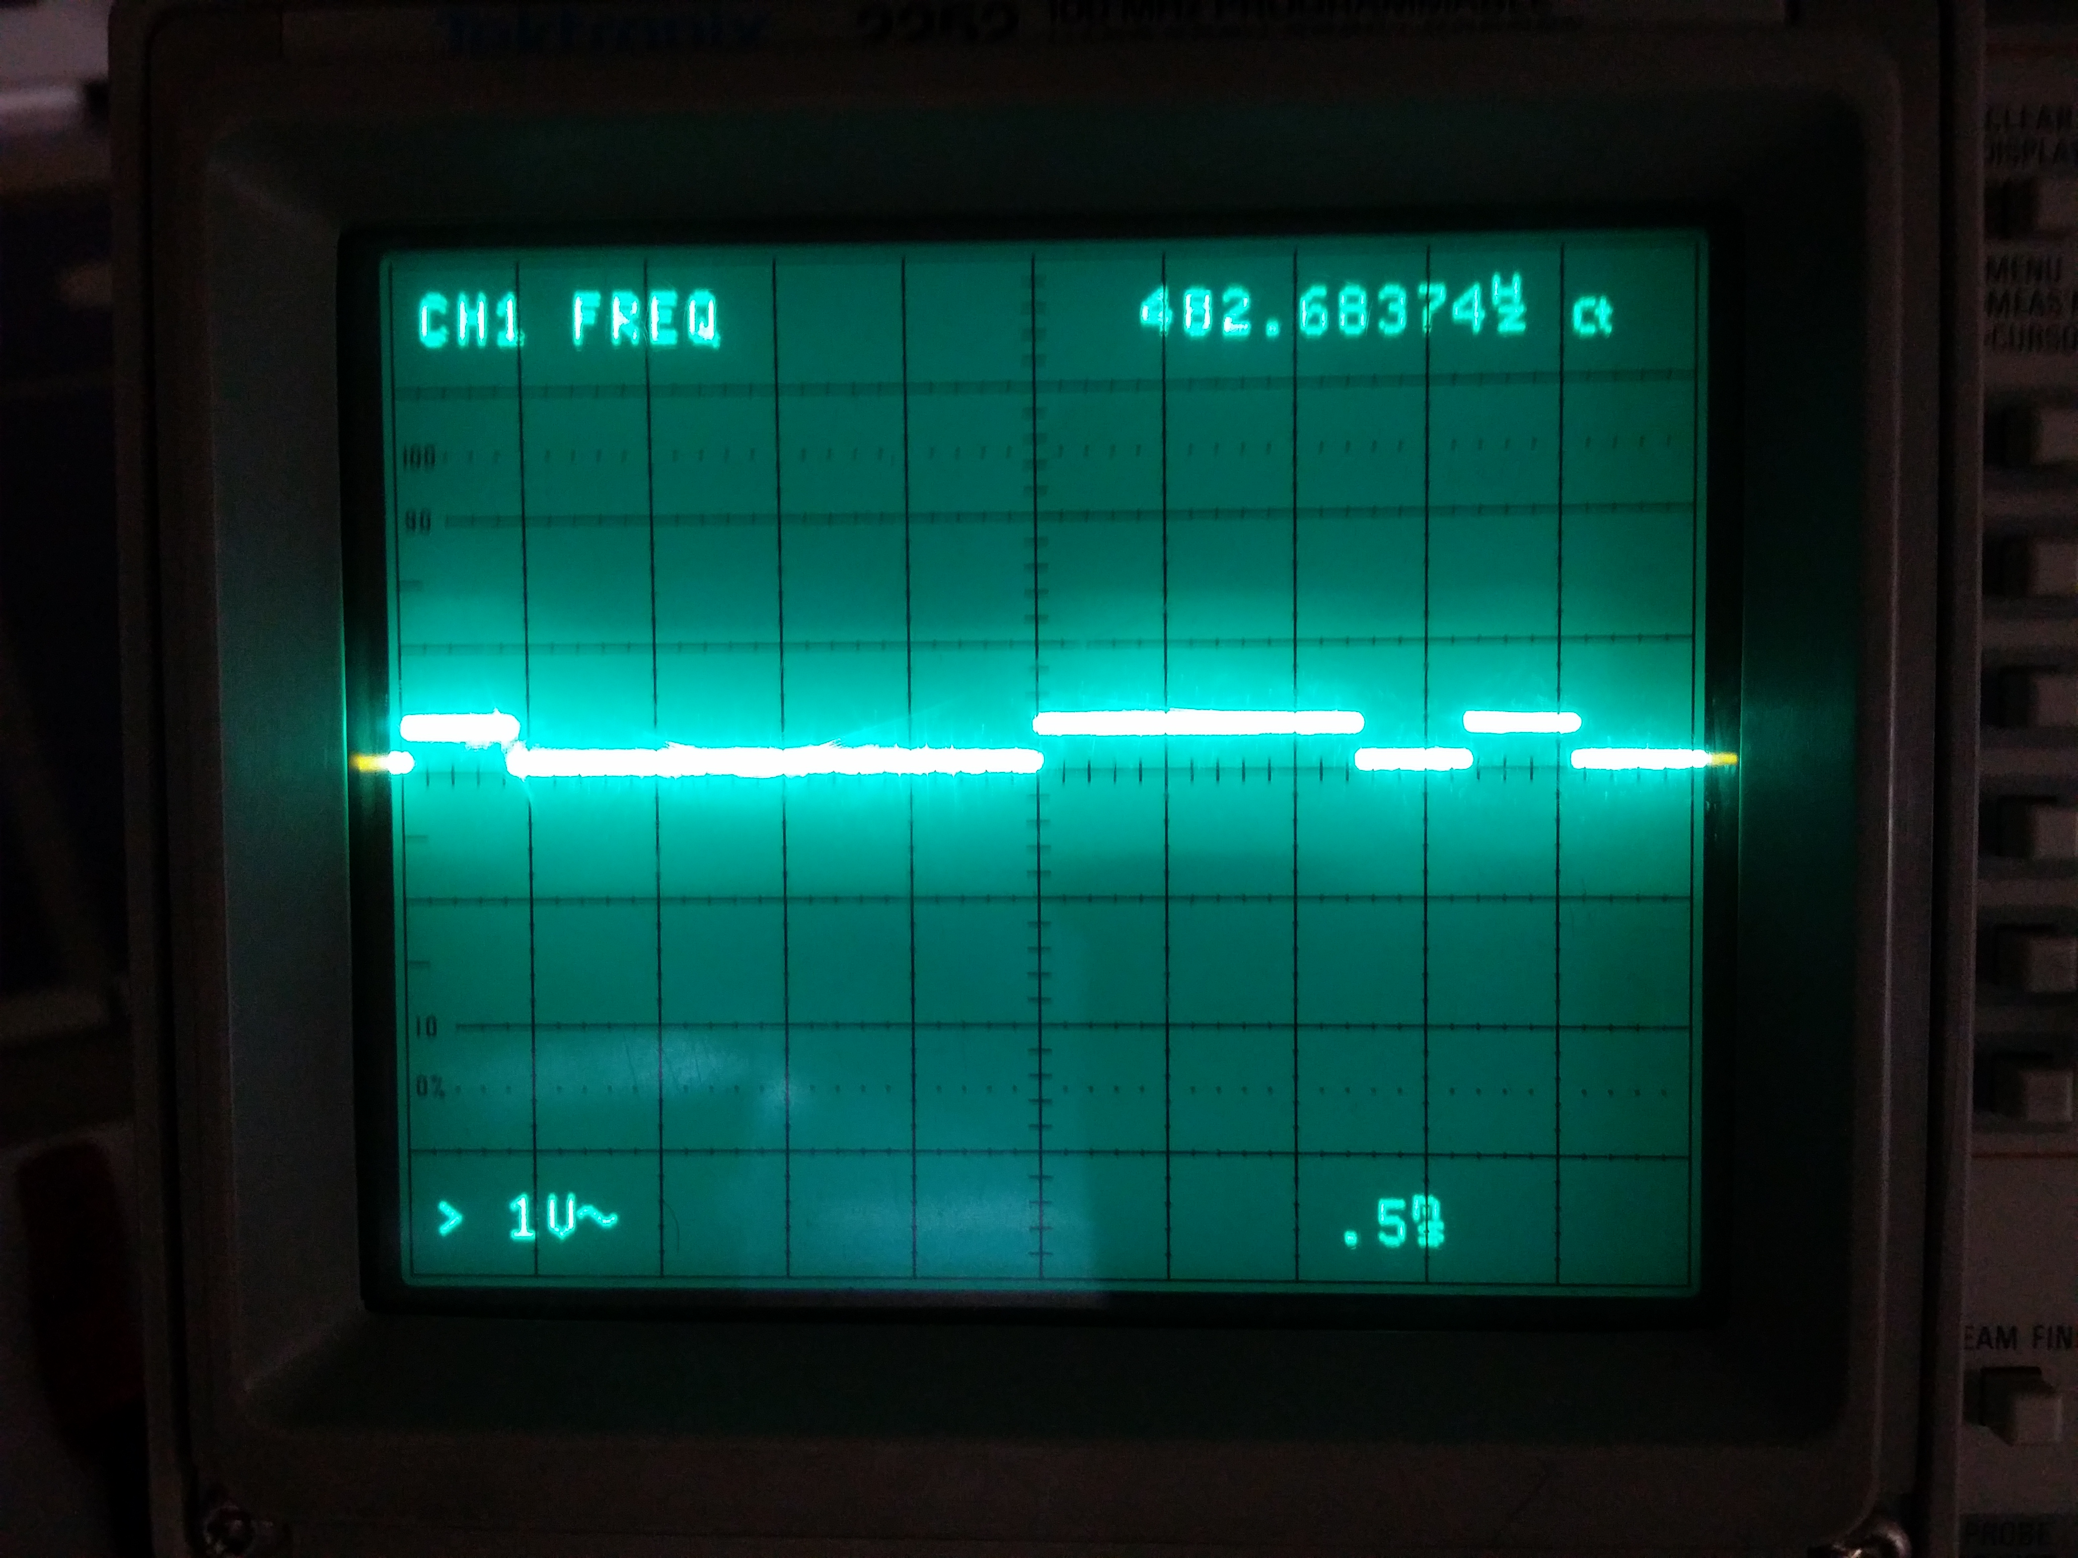

Asterisk character

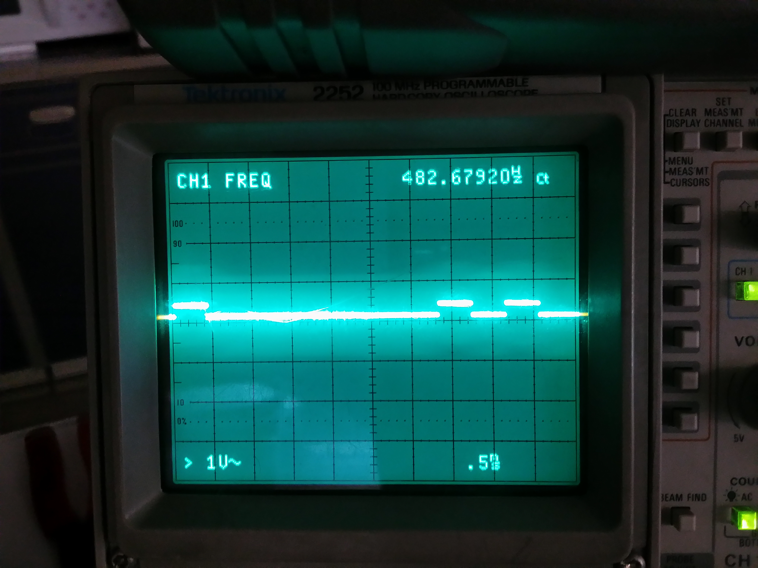

Zero character

Part six and seven are very similar. For part six, a string is printed out to the terminal character by character using the branch and link instruction. This jumps to another location in the code and executes some instructions and then once those are executed, the jump register instruction is called on $ra, which is the return address register that stores the address of the instruction that happens after the branch and link is called.
Part seven is similar to this in that we take an input defined in the code, and then perform some modulo operations to figure out the decimal number, once we have this we then branch and link to the printf function which will print it out for us. Again we ja $ra and keep going. Until we have the number completely decoded and printed out.

III) CONCLUTION

This lab was challenging, first of all because of the way the board interacts with the hardware. Secondly, because of how small the lab is. The real challenging part of the lab was going through all the documentation and finding the memory locations of the registers that held the necessary information that was used and needed for the lab to be completed.
It was also a very fun lab to do, working with the LED PMOD and the echoing UART terminal portions of the lab were the most beneficial and I believe that I learned the most from these portions of the lab.
It's interesting to note that the memory locations of the buttons on the board change depending on which button is pressed. There are not separate registers for the buttons though.

APPENDEX

Part One …............…..................................................File One

Part Two …............…..................................................File Two

Part Three …............…...............................................File Three

Part Four …............….................................................File Four

Part Five …............…..................................................File Five

Part Six …............…...................................................File Six

Part Seven …............…................................................File Seven

